# Functional Design

Team 4

Sander van der Himst

Thom van Mekelenkamp

Arnoud Smit

Jandrik Blom

Batu Demir

Iva Kapel

**Use Case 1:** Registration for customers

**Description**

The customer must be able to register on the website.

**Primary Actor**

The customer

**Supporting Actors**

Plaintech Website

**Pre-Conditions**

* The user must be able to get on the internet
* The website has to be online and working

Success end condition

* User can register an account on the Plaintech website

Failure end condition:

* The user enters a nickname which has already been taken by someone else
* The password chosen does not match the minimal amount of letters, upper case letters or numbers

Minimal Guarantee

- The customer isable to register

Main Success Scenario

- The customer will have an account on Plaintech

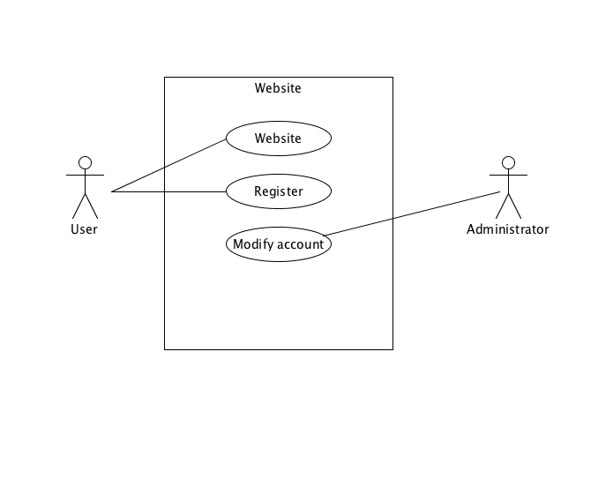

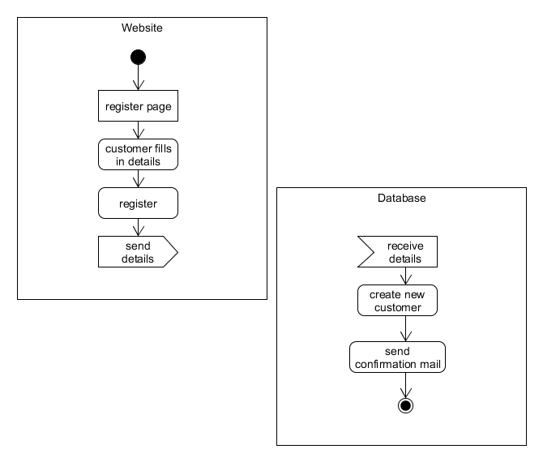

**Use case 2**: Login customer

**Description**

The customer is able to log in to the webpage

**Actors**

Customer, Plaintech

**Post conditions**

Succes end condition

* Customer is logged in
* User goes to the website and sees fast how to change it’s personal data

Failure end condition:

* The website has no connection with the server, login data cannot be authenticated.
* Data is has not processed correctly due invalid data input

Minimal guarentee

* Send a requestion for new password
* Possibility to stay logged in for all upcoming website visits by the customer

Main Succes scenario

* Customer logged in succesfully

Frequency

The customer logs in through the website.

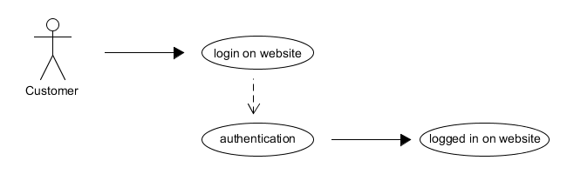

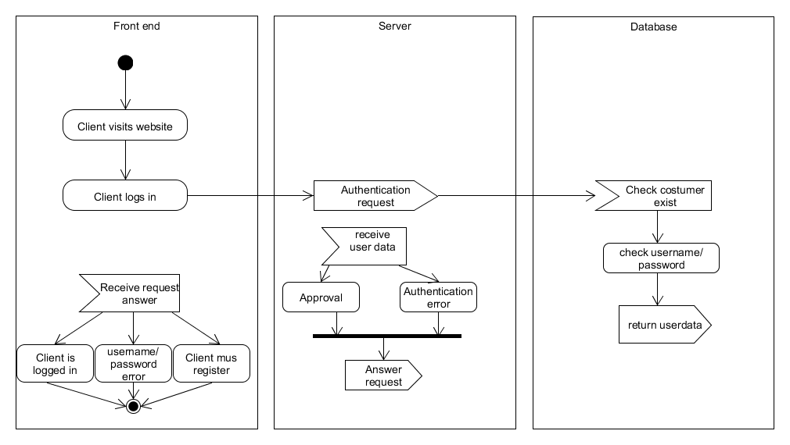

**Use case 3**: Change personal data

**Description**

The customer should be able to change his or her personal data

**Primary** **Actor**

Customer Plaintech

Succes end condition

* User can change it’s personal data
* User goes to the website and sees fast how to change it’s personal data

Failure end condition

* The website has disconnected from the server. It does not receive personal data.
* Data is not processed correctly due wrong data input

Minimal guarentee

* Save personal data for any later changes

Main succes scenario

* Data is precessed succesfull

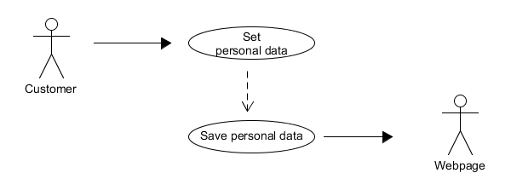

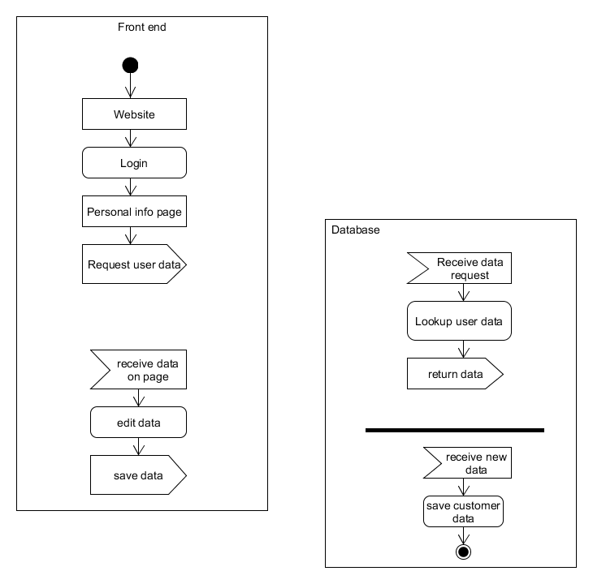

**Use Case 4:** Request new password

**Description**

The customer must be able to request a new password

**Primary Actor**

The customer

**Supporting Actors**

Plaintech Website

**Pre-Conditions**

* The user must be able to get on the internet
* The website has to be online and operational

Success end condition

* User can request a new password on the Plaintech website

Failure end condition:

* The website is offline
* The site crashes
* The user enters the wrong username

Minimal Guarantee

- The customer will get a mail, which contains a temporary link to change his/her password

Main Success Scenario

- The customer will be able to reset his/her password by clicking on the temporary link

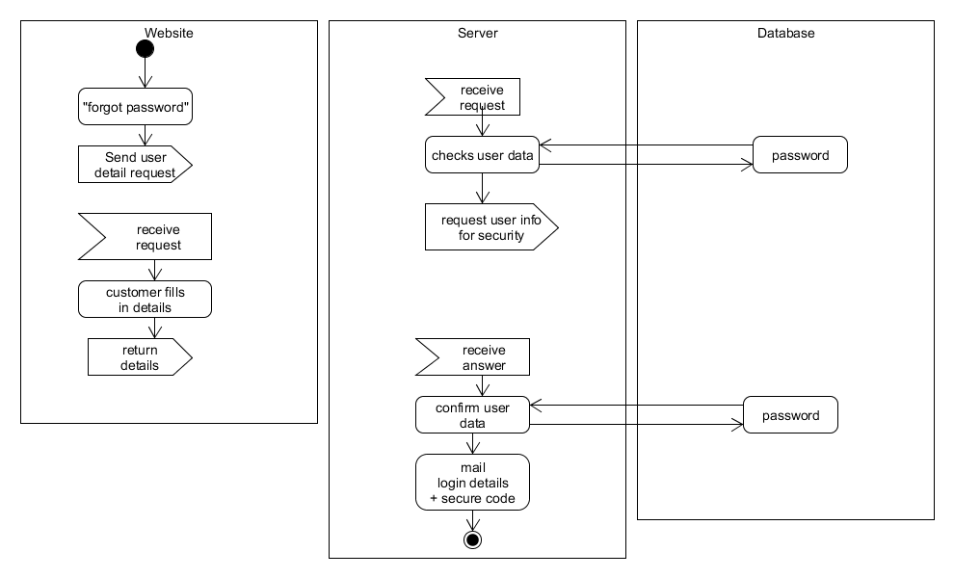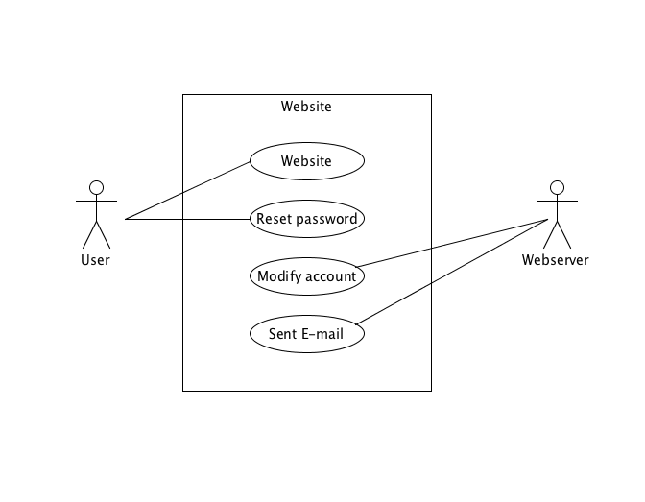

**Use Case 5:** Set VPS configuration

**Description**

The customer can set the settings of his Virtual Private Server before ordering it.

**Primary Actor**

Costumer.

**Secondary Actor**

Plaintech website

**Stakeholders and Interests**

Plaintech.

**Pre-Conditions**

1. Customer has an account
2. Customer is logged in
3. Customer has selected a service level

**Post Conditions**

Success end condition

The customer was able to set his RAM, operating system and storage amount, after which he can save his settings and order his VPS.

Failure end condition:

The customer was unable to save his settings.

Minimal Guarantee

The customer can save his settings.

## Main Success Scenario

1. The customer selects his RAM, OS and storage amount
2. The customer saves his selections

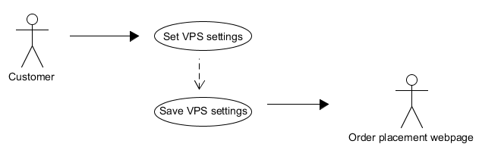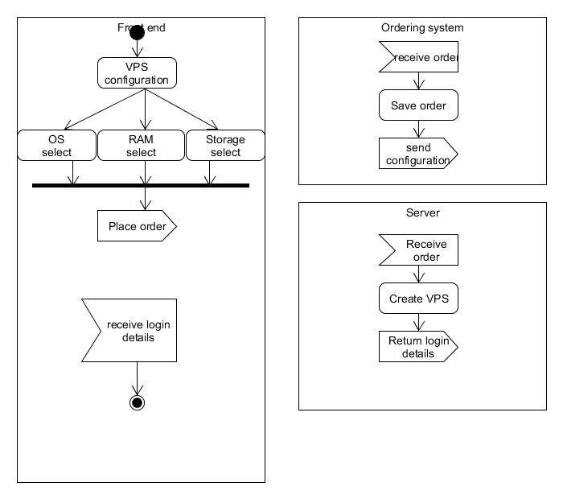

**Use Case 6:** The customer must be able to unsubscribe his virtual machine.

**Description**

The customer must be able to unsubscribe his machine on the website.

**Primary Actor**

The user of the virtual machine.

**Supporting Actors**

Plaintech Website

**Pre-Conditions**

* The user must have access to the internet.
* The website must be functional.

Success end condition

* User can remove the server and its data.
* User goes to the website and can finds out how he can remove his or her server.

Failure end condition:

* The website has no connection with the server, the customer can’t unsubscribe his virtual machine.
* The site crashes
* The website gives incorrect information.

Minimal Guarantee

* The customer can unsubscribe his virtual machine.

Main Success Scenario

1. Unsubscribe virtual machine
2. Easy way of unsubscribing

